Lab # 12
To study GUI forms, event handling, control properties.
GUI FORMS
To create your first Windows form project, click the File menu again. This time, select New Project from the menu. When you do, you'll see the New Project dialogue box again. This one in C# 2017:
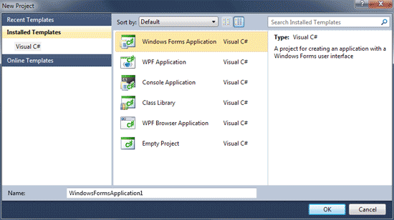

The obvious difference from the Console Application you created in the previous section is the blank Form in the main window. Notice the Toolbox, though, on the left hand side. We'll be adding controls from the Toolbox to that blank Form1 you can see in the image above.If you can't see the Toolbox, you may just see the Tab, as in the following image:
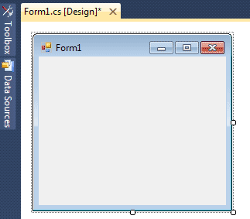
If your screen looks like the one above, move your mouse over to the Toolbox tab. It will expand to look like the first one. If you want to permanently display the Toolbox, click on the pin symbol:
Notice the Solution Explorer on the right side of your screen. (If you can't see the Solution Explorer, click its entry on the View menu at the top of Visual C# Express.) If you compare it with the Solution Explorer when you created your Console Application, you'll see there's only one difference - the Form.
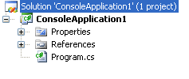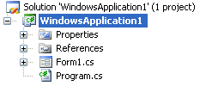

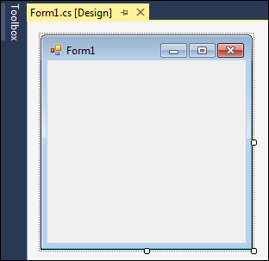
It's in Designer view that we'll be adding things like buttons and text boxes to our form. But you can run this programme as it is. From the Debug menu at the top, click Start Debugging (Or you can just press the F5 key on your keyboard.):
To add a control to a form, you can use the Toolbox on the left of Visual Studio. Move your mouse over to the Toolbox, and click the plus symbol next to Common Controls. You should see the following list of things that you can add to your form:
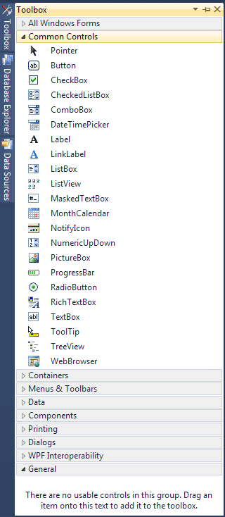
Click the Button item under the Common Controls heading. This will select it. Now click once anywhere on your form.
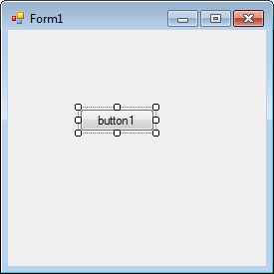
(You can also hold down your left mouse button and drag out a button to the size you want it.)
A button is something you want people to click on. When they do, the code you write gets executed. The text on the button, which defaults to "button1", can be changed. You can add anything you like here, but it should be something that's going to be useful for your users, such as "Open a text file", or "Calculate Now".
The controls you add to a form have something called Properties. A property of a control is things like its Height, its Width, its Name, its Text, and a whole lot more besides. To see what properties are available for a button, make sure the button is selected, as in the image below:
If a control is selected, it will have white squares surrounding it. If your button is not selected, simply click it once.
To view the list of Properties in alphabetical order, click the AZ symbol at the top, circled in red in the image below:
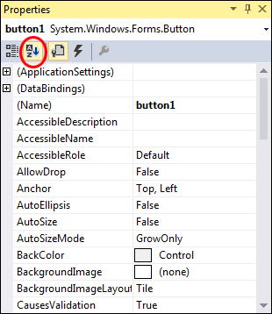
As you can see, there's a lot of Properties for a button. Scroll down to the bottom and locate the TextProperty:
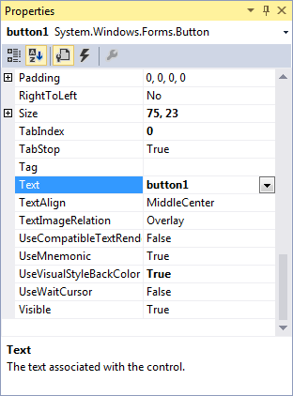
The Text Property, as its name suggests, is the Text you want to appear on the button. At the moment, it says button1. Click inside of the text area of button1. Delete the default text:
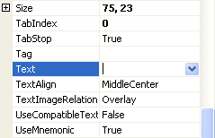
Now type the following:
A Message
The Text part of your Properties Window will then look like this:
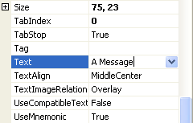
Now press the enter key on your keyboard. Have a look at your Form, and the Text on the button should have changed:
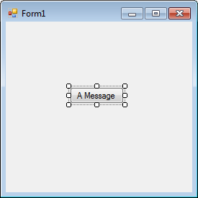
There's a few more Properties we can change before we get to the code.
Locate Size in the Properties Window:
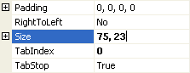
The first number, 75, is the width of the button. The second number, 23, is the height of the button. The two numbers are separated by a comma. Change the numbers to 100, 30:
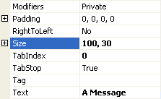
Press the enter key again, and the size of your button will change:
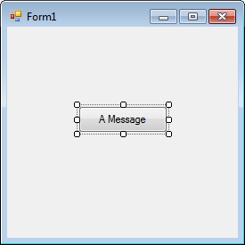
You can move your button around the Form by clicking it with the left mouse button to select it. Hold down you left mouse button and drag your button around the form.

Adding C# Code to a Button
To see the code for the button, double click the button you added to the Form. When you do, the coding window will open, and your cursor will be flashing inside of the button code. It will look like this
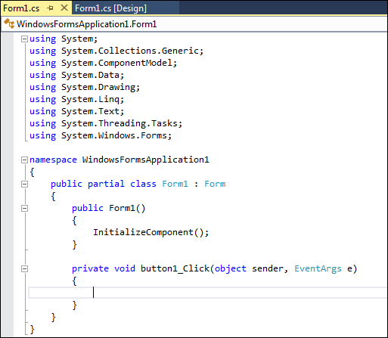
The only difference from the last time you saw this screen is the addition of the code for the button. This code:
private void button1_Click(object sender, EventArgs e)
{
}
This is just another Method, a piece of code that does something. The name of the Method isbutton1_Click. It's called button1 because that's currently the Name of the button. When you changed the Text, Location, and Size properties of the button, you could have also changed the Name property from button1 (the default Name) to something else.
The _Click part after button1 is called an Event. Other events are MouseDown, LocationChanged, TextChanged, and lots more.
We want to display a message box, with some text on it
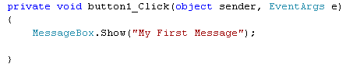

Run your programme by clicking Debug > Start Debugging. Or just press the F5 key on your keyboard. Your programme will look like this:
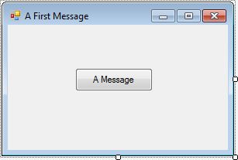
Click your button to see your Message Box:
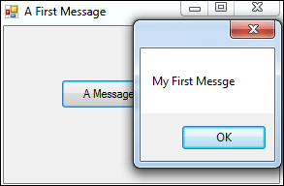
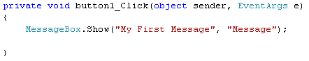
When your line of code looks like the one above, Run your programme again. Click your button and you should see a Title on your Message Box:
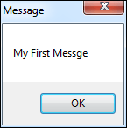

MessageBoxButtons
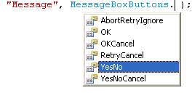
Double click the one for YesNo, and it will be added to your code.
Run your programme again, and click your button. Your Message Box will then look like this:
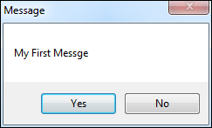

MessageBoxIcon
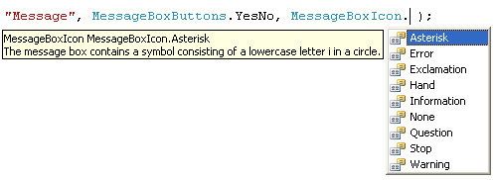
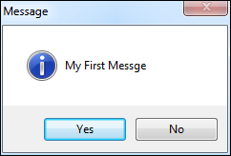

Reading Data From TextBox
Name: btnStrings
Location: 90, 175
Size: 120, 30
Text: Get Text Box Data
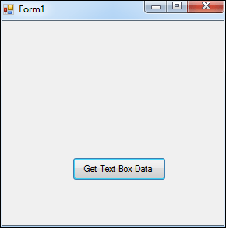
A Label is just that: a means of letting your users know what something is, or what it is for. To add a Label to the form, move your mouse over to the Toolbox on the left. Click the Label item underCommon Controls:
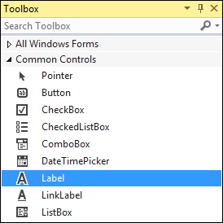
Now click once on your form. A new label will be added:
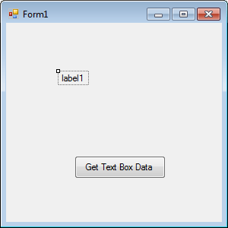

Change the following properties of your label, just like you did for the button:
Location: 10, 50
Text: Name
You don't really need to set a size, because Visual C# will automatically resize your label to fit your text. But your Form should look like this:
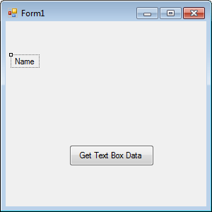
Move your mouse back over to the Toolbox. Click on the TextBox entry. Then click on your form. A new Text Box will be added, as in the following image:
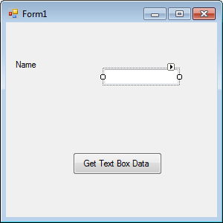
Instead of setting a location for your text box, simply click it with your left mouse button. Hold your left mouse button down, and the drag it just to the right of the Label.
Notice that when you drag your text box around, lines appear on the form. These are so that you can align your text box with other controls on the form. In the image below, we've aligned the text box with the left edge of the button and the top of the Label.
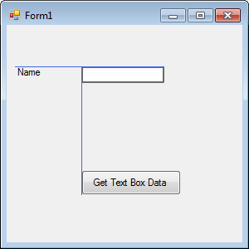

Back to the button code, though. We're going to set up a string variable. To do this, you need two things: the Type of variable you want, and a name for your variable.
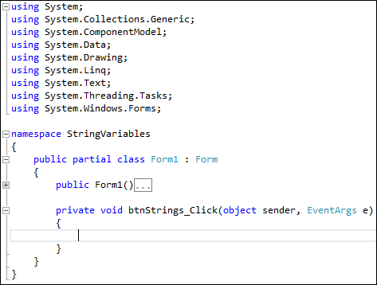
string firstName;
firstName = textBox1.Text;
MessageBox.Show(firstName);

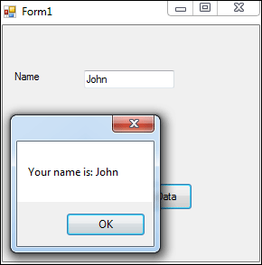

TASKS
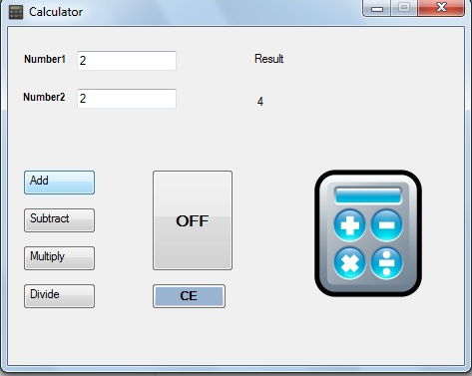
Exercise-2

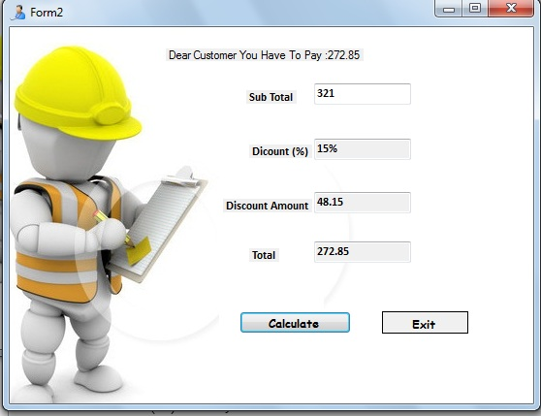
Pressing the Calculate button should give us the following procedure:

Value entered into Subtotal TextBox is transferred to the variable Subtotal.
double Subtotal=Convert.ToDouble(textbox1.Text);

Determine DiscountPercent from the following requirements:
If Subtotal >= 500 then DiscountPercent = 20%.
If Subtotal < 500 and Subtotal >= 250 then DiscountPercent = 15%.
If Subtotal < 250 and Subtotal >= 100 then DiscountPercent = 10%.
Otherwise, DiscountPercent = 0%.

Multiply the Subtotal by the DiscountPercent to get a DiscountAmount.
DiscountAmount = Subtotal * DiscountPercent;

Subtract the DiscountAmount from the Subtotal to get the InvoiceAmount.
InvoiceAmount = Subtotal - DiscountAmount.

Display the DiscountPercent in the DiscountPercent TextBox.
txtDiscountPercent.Text = DiscountPercent.ToString("p1");

Display the DiscountAmount in the DiscountAmount TextBox.
txtDiscountAmount = DiscoutAmount.ToString("c");

Display the InvoiceTotal in the InvoiceTotal TextBox.
txtInvoiceTotal = InvoiceTotal.ToString("c");

